**PUCIT**

**DEPARTMENT OF DATA SCIENCES**

**COMMUNICATION SKILLS**

**RESEARCH REPORT**

**COMMUNICATION THROUGH WORLD’S CUISINES**



**SUBMITTED TO: Ms SAMREEN SHAHID**

**SUBMITTED BY: Muhammad Soban Anjum (BSDSF21A007),**

**Rabail (BSDSF21A032),**

**Hamza Majeed (BSDSF21A016),**

**Muhammad Ahmad (BSDSF21A025)**

**SUBMISSION DATE: 16 November 2022**

**Letter of Transmittal:**

November 13,2022

Ms Samreen Shahid  
Communication and Presentation Skills Ma’am

PUCIT, New Campus,   
West Canal Bank,  
Near SUPARCO

LAHORE

54770

**SUBJECT: Submission of semester report on “Communication through World’s Cuisines.”**

Dear Ms Samreen,

This is to inform you that we have completed the research report that you have assigned us for the course “Communication Skills”. We chose to write our research report on “Communication Through World’s Cuisine” We have discussed different cuisines of various regions of the world including Far eastern, middle East, Subcontinental and European.

Our team has done a lot of hard work and each and every one of us has made efforts to make this research a reliable one. All of us made this report with our collective efforts. We have tried our level best to abide by all rules and guidelines. All of the data used in this report is from authentic and credible resources with credits mention.

Yours sincerely,

Muhammad Soban Anjum

Student

[bsdsf21a007@pucit.edu.pk](mailto:bsdsf21a007@pucit.edu.pk)

+92 303 5151021

**Table of contents:**

Letter of Transmittal (ii)

Table of content (iii)

Acknowledgement (iv)

Executive Summary (v)

1) Introduction (1)

1.1) Introduction to research question (2)

2) Discussion (2)

2.1) Presentation/looks of the food (2)

2.1.1) Service à la française (2)

2.1.2) Service à la russe (3)

2.1.3) Service nowadays (4)

2.1.4) Servings (4)

2.1.5) Eating utensils (4)

2.2) Basic ingredient palette (4)

2.2.1) What is cuisine ingredients? (4)

2.2.2) Basic ingredients (4)

2.2.2.1) Cuisines of North Europe (5)

2.2.2.2) Cuisines of East Europe (5)

2.2.2.3) Cuisines of West Europe (5)

2.2.2.4) Cuisines of South Europe (6)

2.3) Taste of the food (6)

2.3.1) Is European food bland? (6)

2.3.2) Spices (7)

2.4) Theory of comfort food (7)

2.4.1) What is Comfort Food? (7)

2.4.2) Reason to reach out for comfort food: (7)

2.4.3) Comfort foods of Europe: (7)

2.4.3.1) Tartiflette - Savoy, French Alps: (7)

2.4.3.2) Gnocchi - Bellagio, Italy: (8)

2.4.3.3) Speculoos - Belgium/Netherlands/Rhineland: (8)

2.4.3.4) Fondue – Switzerland: (8)

3) Conclusion and Recommendations (8)

4) Bibliography (10)

**Acknowledgement:**

I want to express my gratitude and respect to the course Instructor, Ms. Samreen Shahid. I am so privileged to have Ms. Samreen Shahid as my course instructor. It could not be possible if she had not given her knowledge to us.

I am also grateful for my teammates Hamza Majeed, Ahmed Sheikh and Rabail, who have given their best to make this report possible. Their devotion and hard work make this report possible. Without them I could not have completed this report.

I also want to thank all the bloggers and especially to the encyclopedia (Wikipedia), which helped me so much in my understandings and also provided me with information that I did not have. A special thanks to all the websites and blogs that I read from the internet and their refences are provided at the end.

Lastly, a special thanks to my friends who helped me so much that I can not explain. They also cheered me up, without them I could have lost the track. Their support backed me up and motivated me to complete my work and make this report possible.

This report is written according to best of our knowledge. There can be errors or omissions in this report, but these are totally our responsibility.

**Executive Summary:**

There are various other forms available to communicate – communication through food, culture, sports and music. The dictionary meaning of communication is, “the imparting or exchanging of information by speaking, writing, or using some other medium.”

So how does food come into the context of communication? Well, it does! Food goes beyond a mere act of satiating one’s hunger and nourishing one’s body. It tells us stories. How it is prepared, who sits on the table strengthen bonds between individuals, families, and communities. Family bonds are the strongest and food plays a crucial role in defining this. It defines culture and traditions.

Visit a new place, what is the first thing we try out? The cuisine! And the cuisine tells us stories about the culture. Isn’t that a form of communication?

When we look at European cuisine, it is a reflection of the diversity of Europe. Though quite a complex cuisine, since each state/country has different food preparation styles, techniques, presentations, ingredients, and spices, it clearly talks to us about unity in diversity. It tells us about the culture and the people, the vibrancy! European cuisine is quite a complex cuisine because there are many countries that fall in the region of Europe.

European cuisine evolved from “service à la française” to “service à la russe”. European presentation evolved from service à la française, or bringing multiple dishes to the table at once, into service à la russe, where dishes are presented sequentially. The food is usually presented with red wine and an appetizer is usually served before the whole meal. This appetizer is known as hors d'oeuvre.

European food tends to have more meats, flour, and starchy ingredients. Bread, beef lamb, noodles, butter potatoes are found in European dishes. European people do not like too many spices in their food. Their food is not bland but to a person of spicy tongue, European cuisine might be bland.

Europe is too large, so it is divided into North Europe, South Europe, East Europe, and West Europe. Each of which have different basic ingredients and a different comfort food. In each of the sub region, food might have different tastes, but it all communicates with each other.

Interestingly, there has been some research which shows that food functions symbolically as a means to communicate by which one can create, manage, and share with others. Food is one of the best ways to understand cultures, habits, rituals, and traditions.

1. **Introduction:**

Oxford Dictionary defines food as the following. Any nutrition substance that people or animals eat or drink, or that plant absorb, in order to maintain life and growth. I think this is not the true definition and is not complete. Food is more than just that. This definition is not defining the history, power and even personality of food and condenses it to a simple matter of nutrition whereas food is way more than just that of nutrition. Food is a colorful glimpse into each nation’s history, a helping staff for the weak, comfort for the heart-broken, and a tool that can reconcile the most awkward parties and the bitterest of enemies. What makes food so strong? Maybe the explanation food is so powerful is because on the grounds that it's something that all people share for all intents and purposes, and it permits a human being to speak with other human on the planet, and, surprisingly, animals.

There are now about 7,000 living languages, or languages that are still spoken, according to Ethnologue, a website committed to tracking and monitoring the world's languages. No one alive today could even begin to comprehend being able to speak that many different languages, many are pleased to speak just two. Alexander Arguelles claims to be able to comprehend 38 different languages, and an interview supports his claims. The thirty-eight languages listed here only represent those that he considers to be at least 93% proficient; he is conversant in many more. Alexander describes 93% proficiency as the ability to comprehend at least 14 out of 15 words. Alexander Arguelles, one of the most active language learners in the world, cannot even comprehend what it might be like to speak seven thousand different languages. Despite being extremely amazing, Alexander only spoke 38 languages, or 0.5 percent of all languages in use today.

* 1. **Introduction to Research Question:**

My research question is, “How different cuisines of the world communicate with each other?”. And the sub-topic I am covering is, the European cuisines.

When we say “communication” to a communication professional, the things that come to our minds are strategy, key messages, thought leadership, brand PR, presentations etcetera. Do we step back and think about the various other ways we can communicate besides the usual tools and vehicles? In the regular humdrum of meeting timelines, subtle things that can play a key role in story telling seem to skip our thoughts. There are various other forms available to communicate – communication through food, culture, sports, and music.

Obviously, it’s impossible to be able to speak with anyone in the world and every language in the world, but how about simple communication? At this point, you might be thinking about basic hand communication. Maybe a good ok sign with your fingers? Before you do, I think I should warn you that common American signs mean very different things in different cultures. In Japan, the ok sign (making a circle with your thumb and forefinger and pointing the remaining three up) means money. Now that’s not too bad, is it? but in France, it means zero, and in Brazil, it means something much, much worse. In the Philippines and many other Asian cultures, even beckoning someone over with your pointer finger is a horrible insult, it’s equivalent to calling them a dog.

So, what comes up in your mind? If you cannot speak every language and you cannot even use hands for the communication, then what are you left with? Food, my dear readers, food. A place is usually known for its food. There are many countries where their specific food is famous and even inside a country, different cities are famous for the taste of a specific food or in general a specific food. A person can be defined by his taste for the food or from which country he belongs to. Interestingly, there has been some research which shows that food functions symbolically as a means to communicate by which one can create, manage, and share with others. Food is one of the best ways to understand cultures, habits, rituals, and traditions. I discussed all the things that are for European cuisines. The evolution of European cuisine, the use of utensils and in general basic ingredients used in European cuisines.

1. **Discussion:**

For discussion, I have chosen European cuisines, also known as western cuisines. And I have divided them into sub-parts of presentations and looks, basic ingredients that are used in the make of that food, taste of the European food, and last but not the least, theory of comfort food.

**2.1) Presentation/looks of the food:**

Formal European dinner are served in distinct courses.

**2.1.1) Service à la française:**

Service à la française means “service in French style”. It is the practice of serving various dishes of meal at the same time, with the diners helping themselves from the serving dishes.



(Table layout for the second course, in Elizabeth Raffald's *The Experienced English Housekeeper*, 4th Edition, 1775.)

**2.1.2) Service à la russe:**

The historical form of service à la russe ("service in the Russian style") is a manner of dining that involves courses being brought to the table sequentially, and the food being portioned on the plate by the waiter (usually at a sideboard in the dining room) before being given to the diner. It became the norm in very formal dining in the Western world over the 19th century.

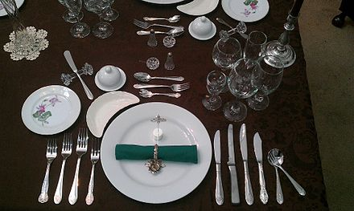

(Service à la russe 8 course place setting for one person)

**2.1.3) European service nowadays:**

European presentation evolved from service à la française, or bringing multiple dishes to the table at once, into service à la russe, where dishes are presented sequentially. Usually, cold, hot, and savory, and sweet dishes are served strictly separately in this order. Dishes that are both sweet and savory were common earlier in Ancient Roman cuisine, but are today uncommon, with sweet dishes being served only as dessert. A service where the guests are free to take food by themselves is termed a buffet and is usually restricted to parties or holidays. Nevertheless, guests are expected to follow the same pattern.

**2.1.4) Servings:**

* An appetizer or starter is small dish that is served before a meal in European Cuisine. Also known as hors d'oeuvre.
* The food is usually served with red wine. European cuisine is enriched with the use of wine.

**2.1.5) Eating utensils:**

The knife was the primary eating implement (cutlery) and eating steaks and other foods that require cutting followed. This contrasted with East Asian cuisine, where the ruling class were the court officials, who had their food prepared ready to eat in the kitchen, to be eaten with chopsticks. The knife was supplanted by the spoon for soups, while the fork was introduced later in the early modern period, ca. 16th century. Today, most dishes are intended to be eaten with cutlery and only a few finger foods can be eaten with the hands in polite company.

**2.2) Basic ingredient palette:**

A cuisine is a style of cooking characterized by distinctive ingredients, techniques, and dishes, and usually associated with a specific culture or geographic region. Regional food preparation techniques, customs, and ingredients combine to enable dishes unique to a region. European food also tends to have more meats flour and starchy ingredients. Bread, beef Lamb, noodles, butter potatoes are found in European dishes but are hardly seen in other countries. Salad is also a major part of the cuisine, as is the ordered meal. Rice and Corn are now part of European food, but they are not traditionally associated nor are they used as staples.

**2.2.1) What are cuisine ingredients?**

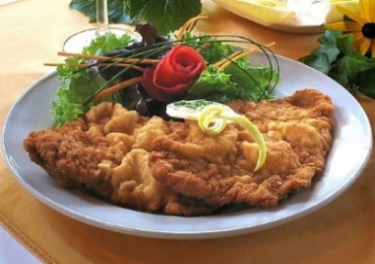A cuisine is partly determined by ingredients that are available locally or through trade. Regional ingredients are developed and commonly contribute to a regional or national cuisine. There are many countries that are included in European cuisine and all of these countries have their specialties.

(An example of Central European cuisine,

the wiener schnitzel.)

**2.2.2) Basic Ingredients:**

The cuisines of Western countries are diverse, although there are common characteristics that distinguish them from those of other regions. Compared with traditional cooking of East Asia, meat is more prominent and substantial in serving size.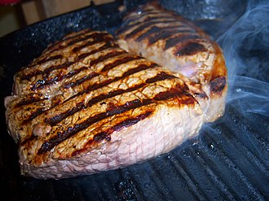 Grape wine is also used in Western/European cuisine. Milk and dairy products are also used as a basic ingredient in European cuisine. Cheese is the main product used in the food (Grilled Steak) of European people. White wheat-flour bread has long been the prestige starch, but historically, most people ate bread, flat cakes, or porridge made from rye, spelt, barley, and oats. In the early modern era, European cuisine saw an influx of new ingredients due to the Columbian Exchange, such as the potato, tomato, eggplant, chocolate, bell pepper, pumpkins, and other squash. Distilled spirits, along with tea, coffee, and chocolate were all popularized during this time. In the 1780s, the idea of the modern restaurant was introduced in Paris; the French Revolution accelerated its development, quickly spreading around Europe. In European cuisines there comes:

**2.2.2.1) Cuisines of North Europe:**



(English cuisine has been influenced by Chinese, Indian and North American. Its main ingredients are bread, cheese, roasted, stewed meats, saltwater fish, chips and malt vinegar.)

North European cuisine, and of course whole Europe is product of a mix of dishes hereditary from the medieval cuisine, which have been changing with the New World discovery increasing new products such as maize, potato, sweet potato, chilies pepper, cocoa, vanilla, tomato, coffee, tea, etc. North Europe is characterized by the production of wheat, which was often used in beer preparation.

**2.2.2.2) Cuisines of East Europe:**



(Russian Cuisine, its main ingredients are mushrooms, bread, made of dozens of wheat varieties, and its principal dishes are exotic soups, and cabbage schi.)

Eastern European Cuisine is product of the economic and industrial development adding to the agrarian way of life, returning to its roots, which means natural and authentic.  
According to the surrounded areas, food may vary, for example, near to Russia and the USSR countries it is rustic and hearty combining with the cold weather. But, in the coastal parts, the food uses more seafood products.

**2.2.2.3) Cuisines of West Europe:**

 

(French Cuisine) (German Cuisine)

The Western European cuisine is a mix of countries: France with its haute cuisine; Germany is known by its beer; Austria famous for Wiener schnitzel, pastries, and coffee culture; Belgium is known for its fried food, chocolates, and waffles; and Switzerland famous for the quality of its chocolates and cheeses.

**2.2.2.4) Cuisines of South Europe:**

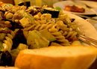

(Greek Cuisine) (Italian Cuisine) (Spanish Cuisine)

Consider one of the richest cuisines in the world; Southern European Cuisine is a combination of many indigenous ingredients with the Mediterranean recipes. Some of their ingredients are wine and herbs like rosemary, thyme, basil, bay laurel, parsley, and sage, tomatoes, garlic, saffron, mustard, anise, capers, olives, anchovies, and pine nuts.

**2.3) Taste of food:**

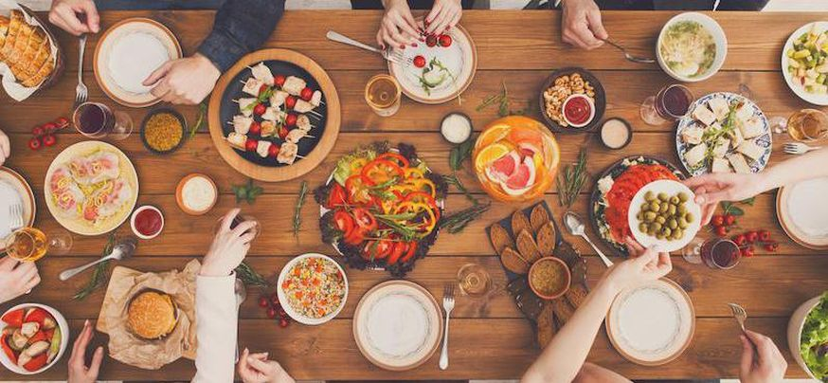

When visiting a traditional European restaurant, take a minute to remember that you’re about to eat something different than what you usually eat. You’re about to enjoy cuisine untouched by modern influences. So, kick back and enjoy the history. Enjoy the culture. Each region of Europe brings something a bit different to their table but it’s all part of the greater western menu. For example, one of the dishes is a Swedish crepe while another is Hungarian goulash. That’s right, Hungarian food is European food. Actually, European cuisine is so wide that it covers all the countries present in Europe. All the countries have something special in their cuisine.

**2.3.1) Is European food bland?**

You’ve enjoyed a traditional British or German dish and found yourself wondering, why is European food so bland? Well, that is just a matter of taste. Every culture’s food is born out of the things that were available. That is how the world enjoys such a wide spectrum of dishes, everyone giving their angle on what was available over the centuries.

Asking why European food is so bland is like asking why Indian food is so spicy. It’s not that one is spicy, or one is bland, you’re describing your flavor assessment of a dish and comparing it to other things you’ve enjoyed. But generally speaking, European food is usually bland but not to the people who are used to the taste of the food.

**2.3.2) Spices:**

There are some fairly spicy foods in most European cuisines, but they are generally the exception rather than the norm. They aren't usually particularly spicy when compared to many Asian dishes, either. Most of it has to do with the fact that spices, including peppers, do not grow well outside of tropical and subtropical climates. Europe did not have any access to spices for most of its history (thus a cultural use of herbs instead) and did not have easy access to spices till modern transportation.

**2.4) Theory of comfort food:**

The accepted belief that comfort food can help you feel better if you're unwell or stressed means that we're likely to accept personal experiences as validation.

**2.4.1) What is Comfort Food?**

The food that provides consolation or a feeling of well-being, typically having a high sugar or carbohydrate content and associated with childhood or home cooking is known as comfort food. It provides a nostalgic or sentimental value to someone, and may be characterized by its high caloric nature, or simple preparation, or high carbohydrate level. The nostalgia may be specific to an individual, or it may apply to a specific culture.

**2.4.2) Reason to reach out for comfort food:**

* Comfort foods trigger dopamine
* Comfort foods gives us social connection
* Comfort foods are associated with positive memories and nostalgia
* Comfort foods can give us a little more certainty and routine.

**2.4.3) Comfort foods of Europe:**

Here are some of the dishes that are considered as comfort foods in the European cuisine:

**2.4.3.1) Tartiflette - Savoy, French Alps:**

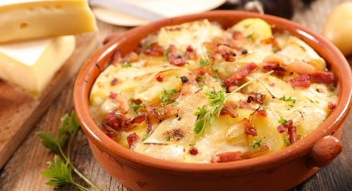The deliciously rich Tartiflette is one of the most popular dishes from this region, and particularly lovely in the colder months. Made using potatoes, reblochon cheese, onions, and lardons, Tartiflette is actually quite a modern dish, based on an older (but less cheesy) French dish called Péla.

**2.4.3.2) Gnocchi - Bellagio, Italy:**

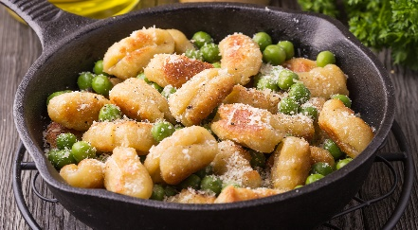

Bellagio in northern Italy sits on the banks of Lake Como. It’s in the Lombardy region, famous for its fantastic food and some of the best wine the country has to offer. Northern Italy is famous for several dishes, such as the deliciously sweet cake, panettone, but also gnocchi. Wonderfully soft, thick dumplings made from dough, gnocchi is an Italian staple since its creation in Roman times.

**2.4.3.3) Speculoos - Belgium/Netherlands/Rhineland:**

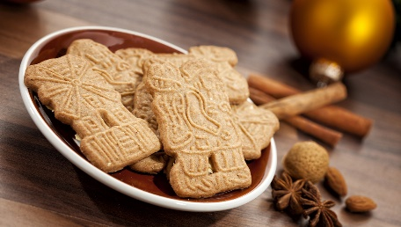There seems to be a recurring theme across Europe when it comes to comfort food dishes – the humble potato. But if you fancy something a little different that will sate your sweet tooth, then take a trip to Belgium, home to the delicious festive biscuit “speculoos”. They’re also equally popular in the Netherlands, where they are spelled “speculaas”, and there is much debate over where they actually come from. Whichever variety you choose to enjoy, they’re largely made the same way with a mixture of festive spices including nutmeg, cinnamon, cloves, cardamom, and anise. The town of Hasselt in Belgium, however, is famed for its special local version created by Antonie Deplée in 1870, which is a kind of almond ‘bread’.

**2.4.3.4) Fondue – Switzerland:**

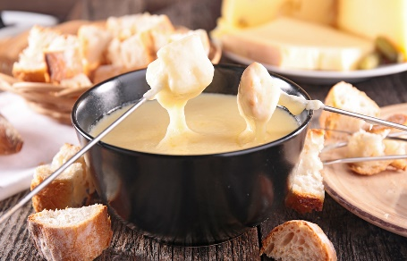Fondue is a popular dish across Europe and beyond, but its original culinary home is Switzerland, even advertised as the Swiss national dish during the 1930s. It has become a popular choice for parties across France and Italy, as well as the perfect meal when you're in need of something comforting. Traditionally, a fondue recipe is to simply melt a selection of your favorite cheeses, add a couple of glugs of white wine and a handful of garlic cloves. After stirring the cheese, simply tear a piece of bread from a freshly baked baguette and dip into the mix.

1. **Conclusion and Recommendation:**

Food has always been seen more as a necessity, a need to survive in everyday life. The food industry rose and started gaining prominence in the twentieth century. There was a newfound interest and fascination with different kinds of cuisines, food magazines, cookery shows on TV, master chefs, food festivals, food bloggers etcetera countless ways to communicate about food. The meaning and relevance of food altered completely. It had changed from the routine ‘have to do’ to an engaging activity which brought to life a special skill. It is no longer only for pure survival, but has a multifaceted dimension attached to it involving both sociological and psychological aspects. This is clearly represented in television, movies, literature, and mass media.

You can not learn all the languages in the world. You cannot speak all the languages in the world. You cannot understand all the languages or cultures of the world. Every region has its own culture and language. But the one thing that connect a human to huma or even to an animal is food. Food is common in every region. Everyone eats food and food also have the history and culture embedded into it.

Food can also be the main source of communication. As I have already explained the importance of food. Food is the source of nutrients, but it is also the source of communication. European people do not eat spicy food. They like less spicy or bland food. It seems bland to especially Asian people because Asian cuisine are spicy in nature as compared to European cuisines.

European cuisine involves the use of red wine. Red wine is widely used in European cuisine. Meat is widely used. Europe have the one of the best tasting steaks. Food also provides comforts. There is a theory of comfort food, the food which is nostalgic and usually the specialty of that certain region is known as comfort food. As Europe is too large, so the south, west, east, and north Europe have different comfort foods.

Lastly, it is concluded that food functions symbolically as a means to communicate by which one can create, manage, and share with others. Food is one of the best ways to understand cultures, habits, rituals, and traditions.

**Here are some recommendations for a Foodie:**

* Wherever you go try to experience as much food as you can.
* European food is not bland, it’s just the taste of your tongue.
* Always try the comfort food of that particular region.
* Do not think that the street food is bad, try street food. In most of cases street food is much tastier than a porch restaurant food.

1. **Bibliography:**
2. <https://writetheworld.org/groups/1/shared/7286/version/15968>
3. <https://reputationtoday.in/food-as-a-form-of-communication/#:~:text=Interestingly%2C%20there%20has%20been%20some,%2C%20habits%2C%20rituals%20and%20traditions>
4. <https://en.wikipedia.org/wiki/Cuisine>
5. <https://en.wikipedia.org/wiki/European_cuisine>
6. <https://en.wikipedia.org/wiki/Comfort_food>
7. Food as Communication- Communication as Food by Janet M. Cramer ©2011